**Manual Test for Portfolio**

1. Open a browser and enter [localhost:8000](http://localhost:8000). Verify that it looks like this:

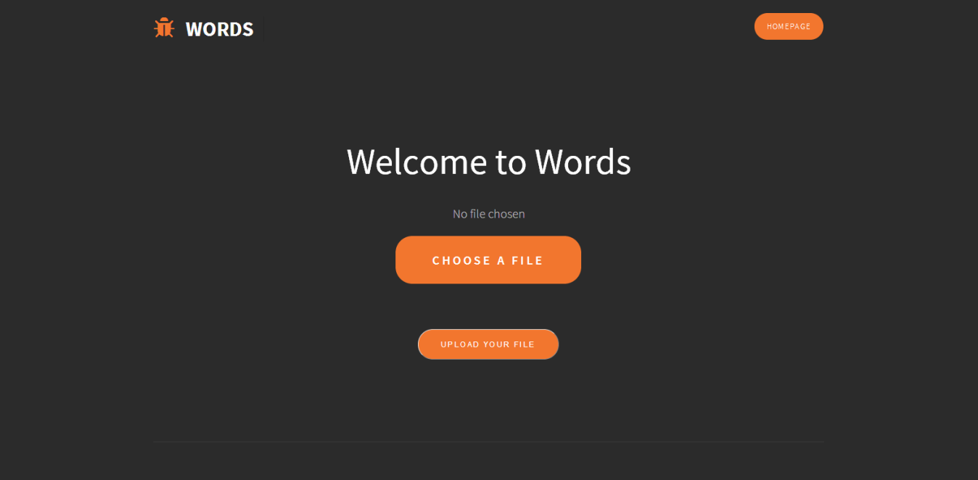

1. Click on “Choose A File”. Verify that a file explorer similar to the one below appears:

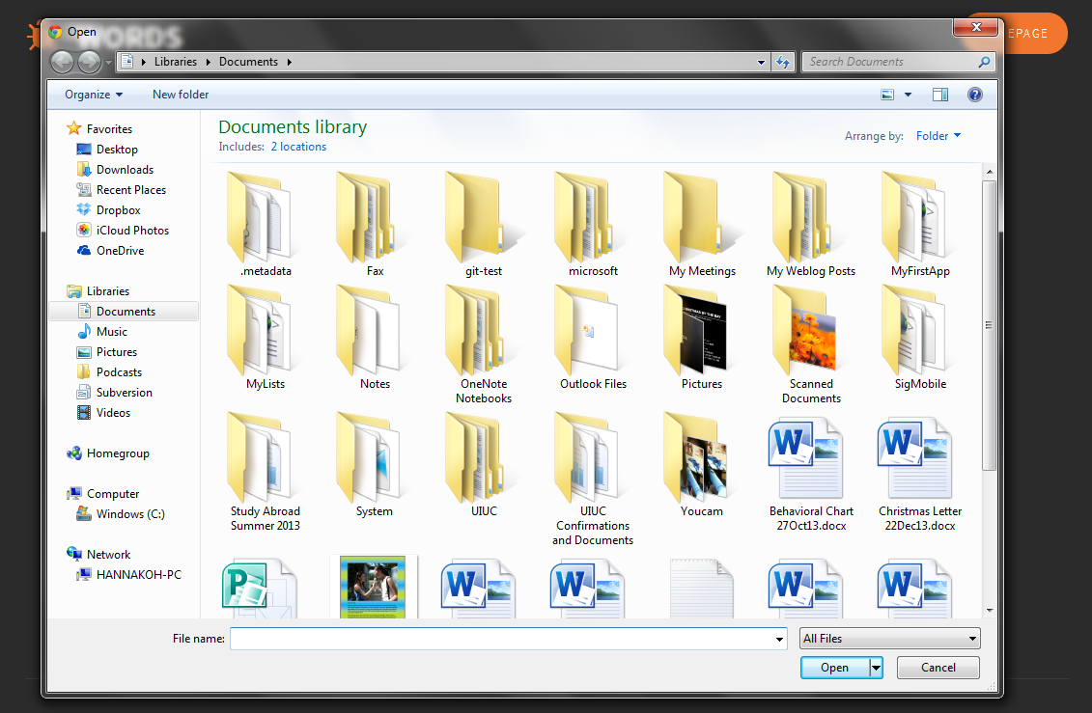

1. Select “test.txt”. Verify that the text above the “Choose A File” button is replaced by the file path.

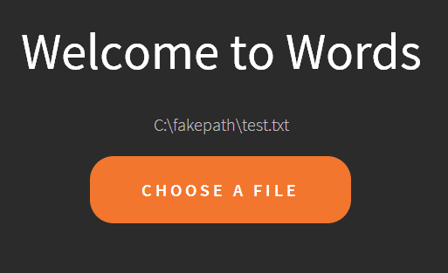

1. 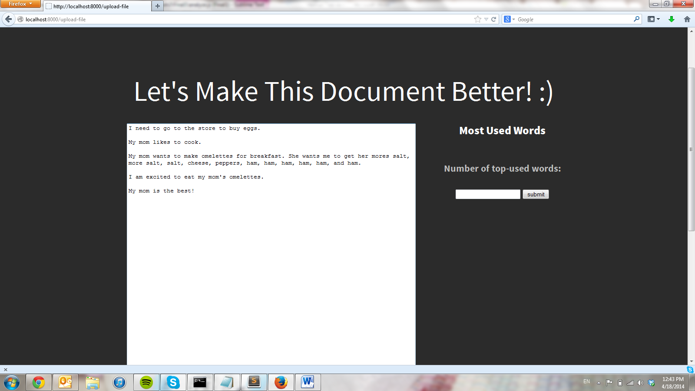Click on “Upload Your File”. Verify that you go to the following page.
2. 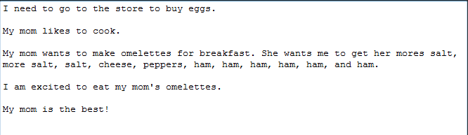Verify that text area has the following text.
3. 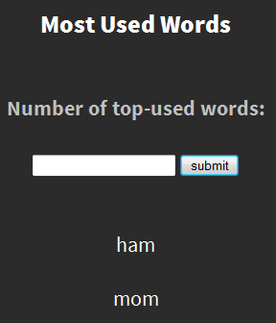In the form on the right under “Most Used Words”, enter the number 2 and press submit. Verify that the following shows up and that the form resets. Verify that the page doesn’t reload.
4. Now enter the number 100 in the form and press submit. Verify that there are no errors and the website doesn’t crash. Verify that you get the following output. Verify that the page doesn’t reload.

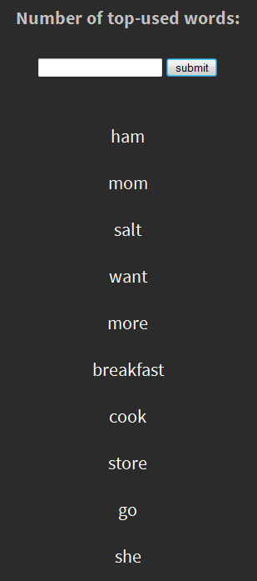

1. 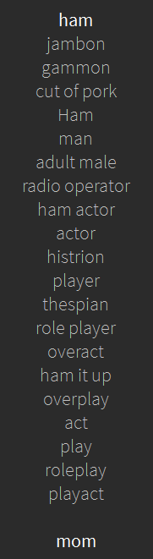Click on “ham” verify that the following shows up. Verify that when you click “ham” again, it disappears.
2. Type “I am adding more” at the end of the text in the text area. Verify that you can do this.
3. Click on the “Download” button under the text area. Verify that you can download the changes and that the .txt document shows up as follows:

